

# Report

# Hydra FM Bottom Enclosure Seal Apr 19, 2013

**FEA Study and Concept Test**

**Summary:**

The lower enclosure seal to the upper enclosure depends on compressing an over-molded seal bead. The plastic bottom enclosure was studied to ensure it was stiff enough to compress the seal.

An enclosure with similar structural features but using an o-ring (compressed to similar forces) was machined, assembled, inspected for excessive deflection, and dunk tested.

**Objectives:**

1. Quantify the forces/pressure to compress the over-molded seal.
2. Evaluate the deflection of the lower enclosure at the seal-compression forces.
3. Verify no large deflection of the enclosure structural features, at the battery end (the longest span between screws) and along the sides.
4. Verify using plastic washers to seal under the enclosure screws.
5. Verify enclosure seal conditions of a similar arrangement to the current design

**Calculations, Results and Observations:**

1. Quantify the forces/pressure to compress the over-molded seal.

Measuring the force vs. deflection for the over-molded seal bead on the Guardian bottom enclosure gave a spring rate of 520 lbf/in. Assuming a similar design feature set for the FM seal bead, with a larger deflection of 0.030 inches, the deflection force is estimated to be 13.2 lbf/in. See Figure 1, Seal Force Calculations (attached). Figures 2 – 5 show studies of the seal.

1. Evaluate the deflection of the lower enclosure at the seal-compression forces.

Stiffening features were added and the lower enclosure material was changed to 30% glass filled. Figure 6 shows deflection analysis of the stiffening features, using 30% glass filled cycoloy.

From this study we concluded seal forces would defect the cover approximately 0.010. A bow of 0.02 (as well as hardstops to limit compression at .02) was added to the seal bearing surface at the battery end

**Conclusions and Recommendations:**

All of the materials were resistant enough to endure the chemical test.

The silicon and the viton are primary candidates for replacing the current material due to compression set issues. The silicon appeared to be the least affected, and is recommended.

**Test Setup and Procedure:**

1 mL of 2% Liquinox solution, 10% Sodium Hydroxide solution, 10% Calcium Hypochlorite solution, and 2% Detergent 8 were placed into separate 2 mL vials. A sample of each material was placed into a vial. Test time was measured with a timer. At the end of the test time, the samples were removed from the vials, rinsed with filtered water, and blotted with paper towels to remove excess liquid.

The test samples visually inspected, rubbed on to check for change to abrasion resistance and material continuity, and stretched to check for change to elasticity.

The samples were placed in separate plastic bags, and inspected again and photographed two days later.

Figure 01 shows the chemical test in process.

Note that the Calcium Hypochlorite solution was cloudy, indicating the crystals did not all dissolve (in standard conditions), but that the solution was saturated. Actual concentration could not be determined.

Tables 1 and 2 give the observations for each test.

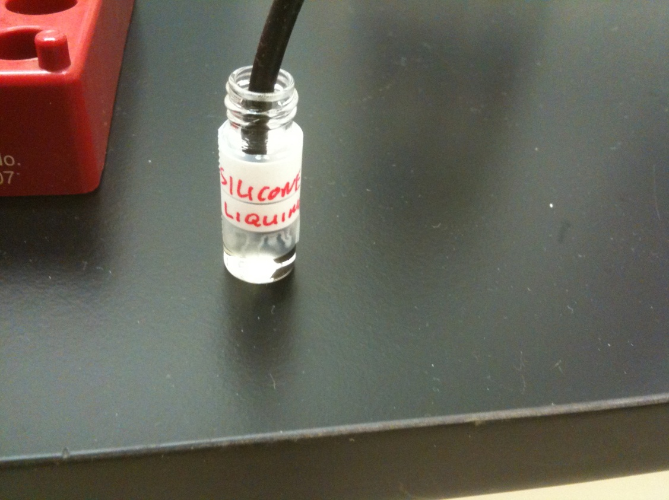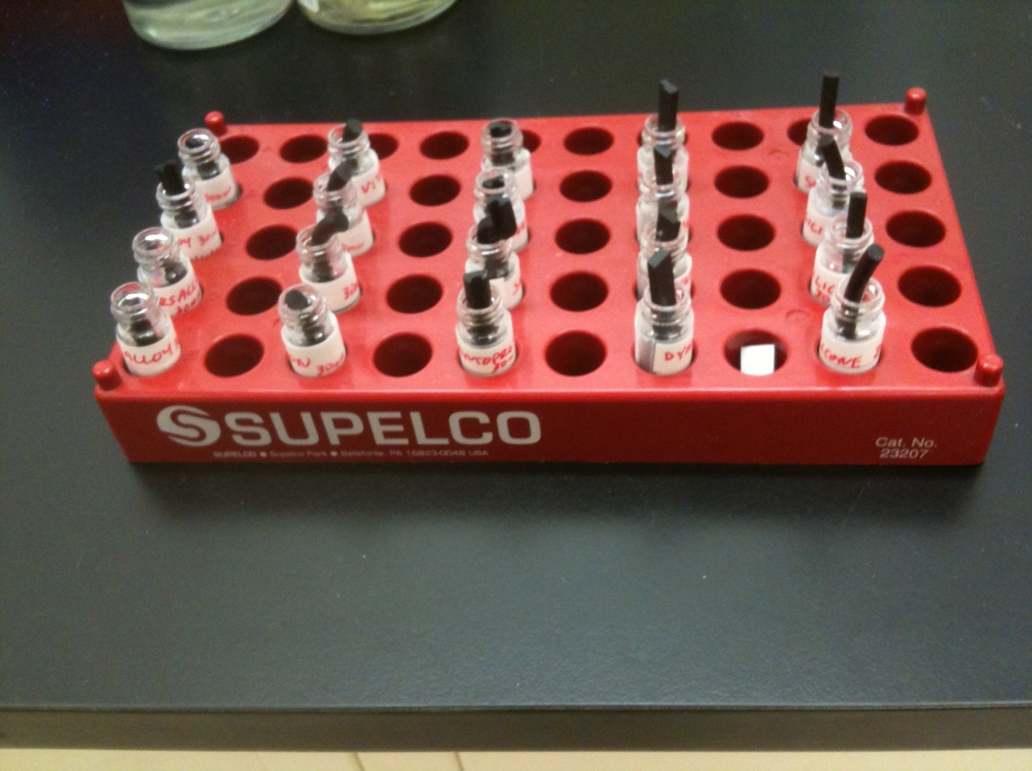

Figure 1. 30 Minute Test In Process

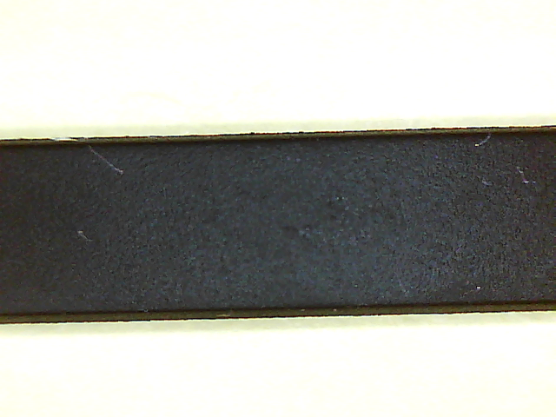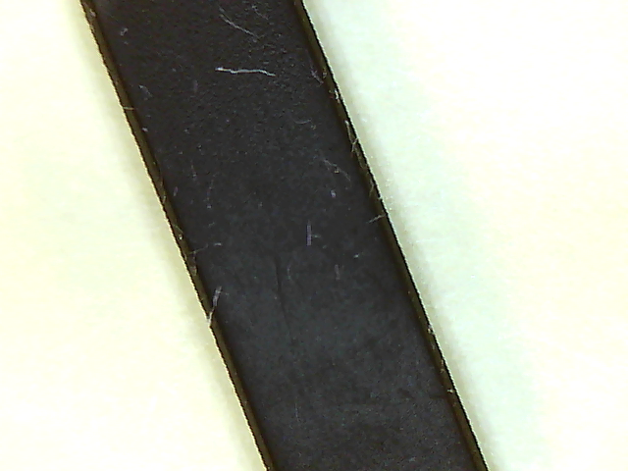

Figure 2. Versalloy in Liquinox Figure 3. Versalloy in Detergent 8

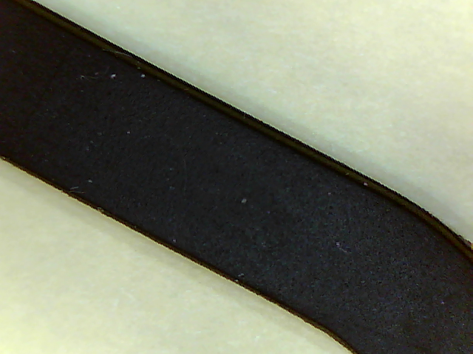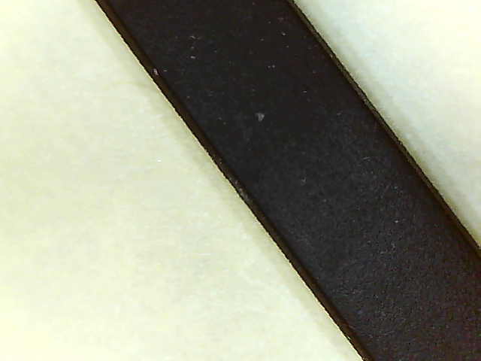

Figure 4. Versalloy in Calcium Hypochlorite Figure 5. Versalloy in Sodium Hydroxide

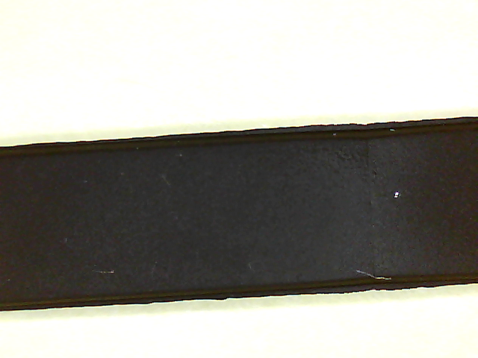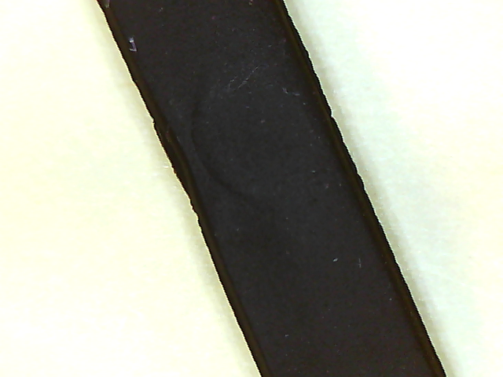

Figure 6. Santoprene in Liquinox Figure 7. Santoprene in Detergent 8

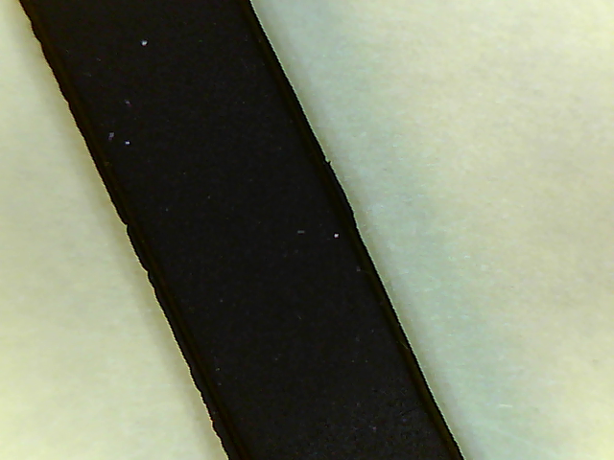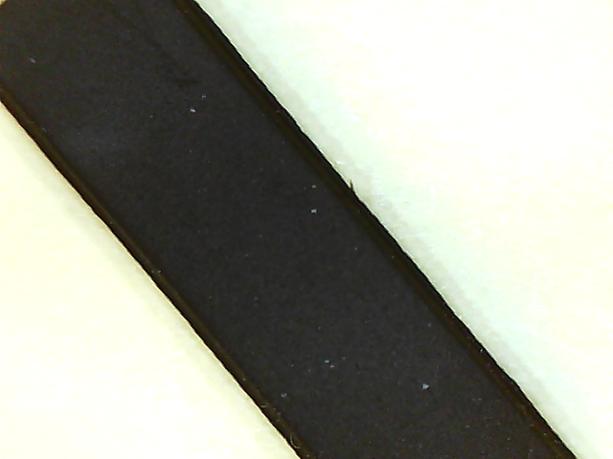

Figure 8. Santoprene in Calcium Hypochlorite Figure 9. Santoprene in Sodium Hydroxide

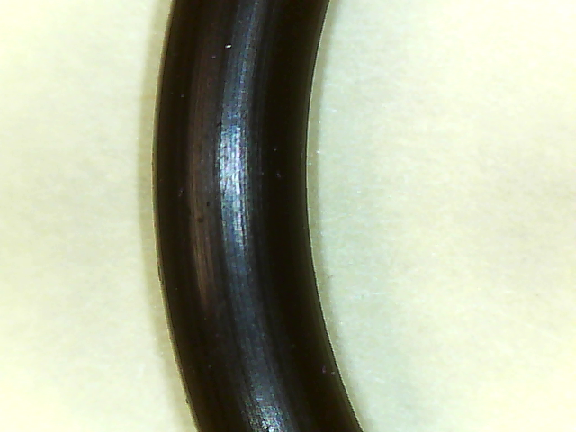 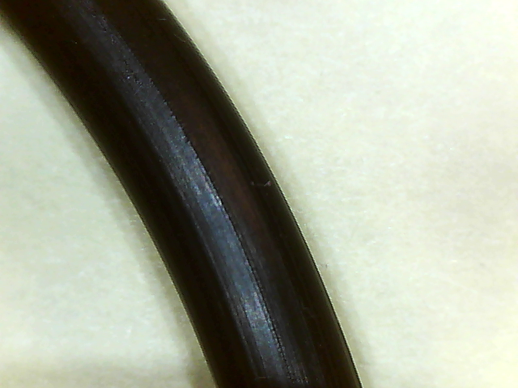

Figure 10. Viton in Liquinox Figure 11. Viton in Detergent 8

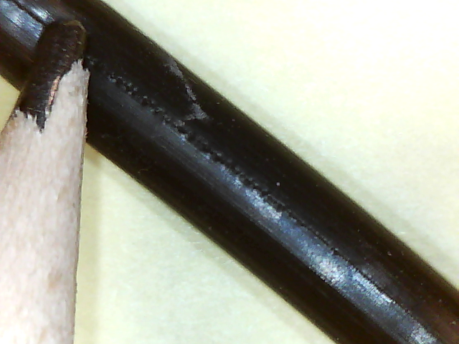 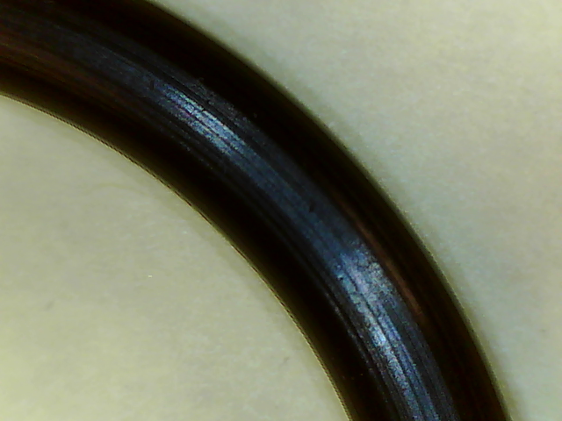

Figure 12. Viton in Calcium Hypochlorite Figure 13. Viton in Sodium Hydroxide

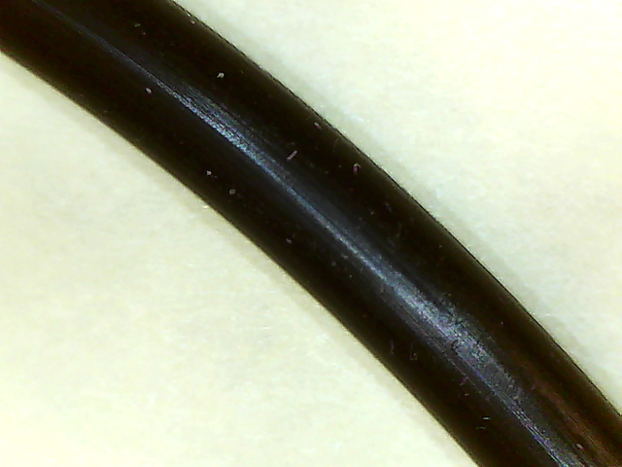 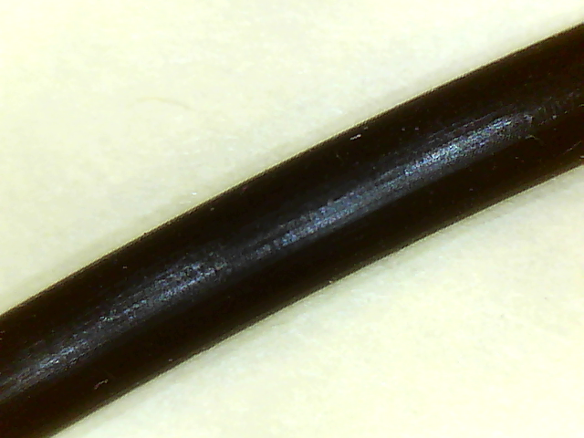

Figure 14. Silicon in Liquinox Figure 15. Silicon in Detergent 8

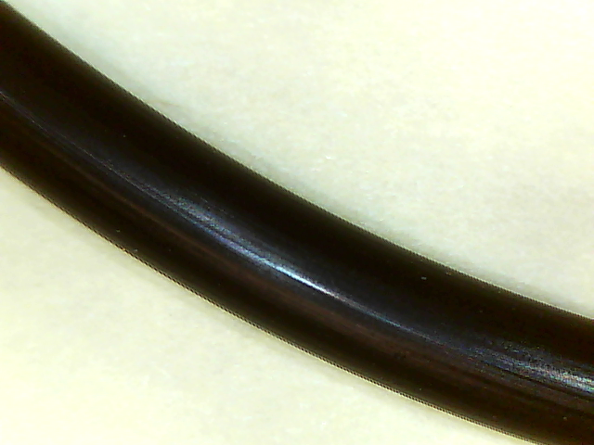 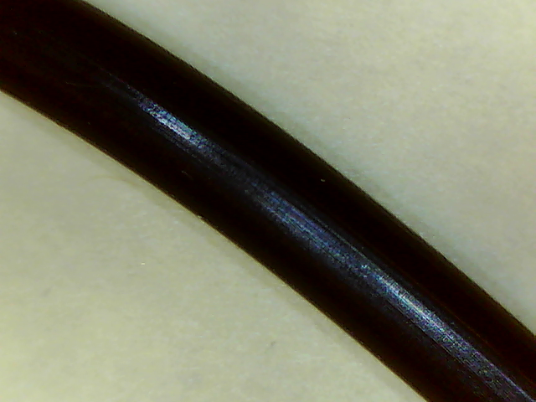

Figure 16. Silicon in Calcium Hypochlorite Figure 17. Silicon in Sodium Hydroxide

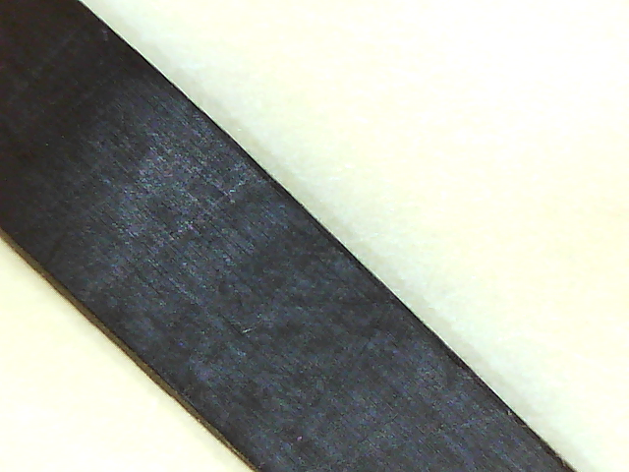 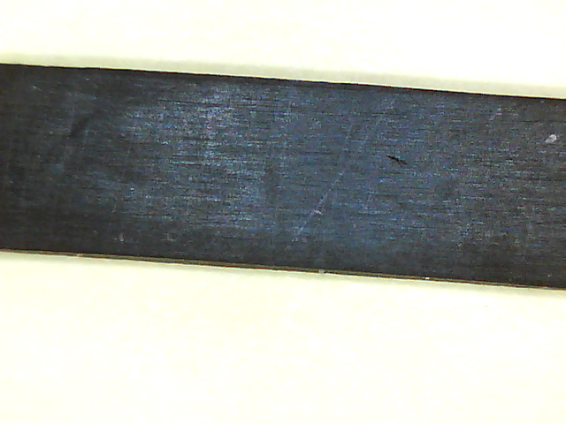

Figure 18. Dynaflex in Liquinox Figure 19. Dynaflex in Detergent 8

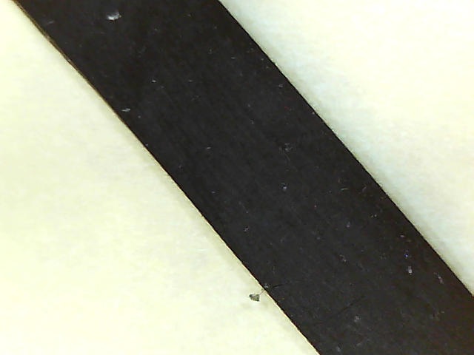 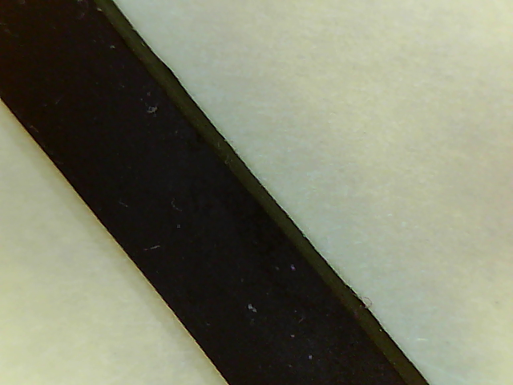

Figure 20. Dynaflex in Calcium Hypochlorite Figure 21. Dynaflex in Sodium Hydroxide

­­

### Report prepared by:

George Riehm Mar 10, 2013

Nexus Design LLC

Oxford, CT 06478